**Assignment 5**

**Name: Nikhil Girish**

**SRN: PES2UG21CS334**

**Sem: III Sec: F**

**Code:**

Alu.v:

module alu_slice (input wire [1:0] op, input wire i0, i1, cin, output wire o, cout); wire t_sumdiff, t_and, t_or, t_andor; addsub _i0 (op[0], i0, i1, cin, t_sumdiff, cout); and2 _i1 (i0, i1, t_and); or2 _i2 (i0, i1, t_or); mux2 _i3 (t_and, t_or, op[0], t_andor); mux2 _i4 (t_sumdiff, t_andor, op[1], o); endmodule

module alu (input wire [1:0] op, input wire [15:0] i0, i1, output wire [15:0] o, output wire cout); wire [14:0] c; alu_slice _i0 (op, i0[0], i1[0], op[0] , o[0], c[0]); alu_slice _i1 (op, i0[1], i1[1], c[0], o[1], c[1]); alu_slice _i2 (op, i0[2], i1[2], c[1], o[2], c[2]); alu_slice _i3 (op, i0[3], i1[3], c[2], o[3], c[3]); alu_slice _i4 (op, i0[4], i1[4], c[3], o[4], c[4]); alu_slice _i5 (op, i0[5], i1[5], c[4], o[5], c[5]); alu_slice _i6 (op, i0[6], i1[6], c[5], o[6], c[6]); alu_slice _i7 (op, i0[7], i1[7], c[6], o[7], c[7]); alu_slice _i8 (op, i0[8], i1[8], c[7], o[8], c[8]); alu_slice _i9 (op, i0[9], i1[9], c[8], o[9], c[9]); alu_slice _i10 (op, i0[10], i1[10], c[9] , o[10], c[10]); alu_slice _i11 (op, i0[11], i1[11], c[10], o[11], c[11]); alu_slice _i12 (op, i0[12], i1[12], c[11], o[12], c[12]); alu_slice _i13 (op, i0[13], i1[13], c[12], o[13], c[13]); alu_slice _i14 (op, i0[14], i1[14], c[13], o[14], c[14]); alu_slice _i15 (op, i0[15], i1[15], c[14], o[15], cout);

endmodule

lib.v: module invert (input wire i, output wire o); assign o = !i;

endmodule

module and2 (input wire i0, i1, output wire o); assign o = i0 & i1; endmodule

module or2 (input wire i0, i1, output wire o); assign o = i0 | i1;

endmodule

module xor2 (input wire i0, i1, output wire o); assign o = i0 ^ i1; endmodule

module nand2 (input wire i0, i1, output wire o); wire t; and2 and2_0 (i0, i1, t); invert invert_0 (t, o);

endmodule

module nor2 (input wire i0, i1, output wire o); wire t; or2 or2_0 (i0, i1, t); invert invert_0 (t, o);

endmodule

module xnor2 (input wire i0, i1, output wire o); wire t; xor2 xor2_0 (i0, i1, t); invert invert_0 (t, o);

endmodule

module and3 (input wire i0, i1, i2, output wire o); wire t; and2 and2_0 (i0, i1, t); and2 and2_1 (i2, t, o);

endmodule

module or3 (input wire i0, i1, i2, output wire o); wire t; or2 or2_0 (i0, i1, t);

or2 or2_1 (i2, t, o);

endmodule

module nor3 (input wire i0, i1, i2, output wire o); wire t; or2 or2_0 (i0, i1, t); nor2 nor2_0 (i2, t, o);

endmodule

module nand3 (input wire i0, i1, i2, output wire o); wire t; and2 and2_0 (i0, i1, t); nand2 nand2_1 (i2, t, o); endmodule

module xor3 (input wire i0, i1, i2, output wire o); wire t; xor2 xor2_0 (i0, i1, t); xor2 xor2_1 (i2, t, o);

endmodule

module xnor3 (input wire i0, i1, i2, output wire o); wire t; xor2 xor2_0 (i0, i1, t); xnor2 xnor2_0 (i2, t, o);

endmodule

module mux2 (input wire i0, i1, j, output wire o); assign o = (j==0)?i0:i1; endmodule

module mux3 (input wire [0:2] i, input wire j1, j0, output wire o); wire t; mux2 mux2_0 (i[0], i[1], j0, t); mux2 mux2_1 (t, i[2], j1, o);

endmodule

module mux4 (input wire [0:3] i, input wire j1, j0, output wire o); wire t0, t1; mux2 mux2_0 (i[0], i[1], j1, t0); mux2 mux2_1 (i[2], i[3], j1, t1); mux2 mux2_2 (t0, t1, j0, o); endmodule

module mux8 (input wire [0:7] i, input wire j2, j1, j0, output wire o); wire t0, t1; mux4 mux4_0 (i[0:3], j2, j1, t0); mux4 mux4_1 (i[4:7], j2, j1, t1); mux2 mux2_0 (t0, t1, j0, o); endmodule

module demux2 (input wire i, j, output wire o0, o1); assign o0 = (j==0)?i:1'b0; assign o1 = (j==1)?i:1'b0; endmodule

module demux4 (input wire i, j1, j0, output wire [0:3] o); wire t0, t1; demux2 demux2_0 (i, j1, t0, t1); demux2 demux2_1 (t0, j0, o[0], o[1]); demux2 demux2_2 (t1, j0, o[2], o[3]); endmodule

module demux8 (input wire i, j2, j1, j0, output wire [0:7] o); wire t0, t1; demux2 demux2_0 (i, j2, t0, t1); demux4 demux4_0 (t0, j1, j0, o[0:3]); demux4 demux4_1 (t1, j1, j0, o[4:7]); endmodule

module df (input wire clk, in, output wire out); reg df_out; always@(posedge clk) df_out <= in; assign out = df_out; endmodule

module dfr (input wire clk, reset, in, output wire out); wire reset_, df_in; invert invert_0 (reset, reset_); and2 and2_0 (in, reset_, df_in); df df_0 (clk, df_in, out);

endmodule

module dfrl (input wire clk, reset, load, in, output wire out); wire _in; mux2 mux2_0(out, in, load, _in);

dfr dfr_1(clk, reset, _in, out);

endmodule

module dfs (input wire clk, set, in, output wire out); wire dfr_in,dfr_out; invert invert_0(in, dfr_in); invert invert_1(dfr_out, out); dfr dfr_2(clk, set, dfr_in, dfr_out);

endmodule

module dfsl (input wire clk, set, load, in, output wire out); wire _in; mux2 mux2_0(out, in, load, _in); dfs dfs_1(clk, set, _in, out);

endmodule

module fa (input wire i0, i1, cin, output wire sum, cout); wire t0, t1, t2; xor3 _i0 (i0, i1, cin, sum); and2 _i1 (i0, i1, t0); and2 _i2 (i1, cin, t1); and2 _i3 (cin, i0, t2); or3 _i4 (t0, t1, t2, cout);

endmodule

module addsub (input wire addsub, i0, i1, cin, output wire sumdiff, cout); wire t; fa _i0 (i0, t, cin, sumdiff, cout); xor2 _i1 (i1, addsub, t);

endmodule

mproc.v: module nor5 (input wire [0:4] i, output wire o); wire t; or3 or3_0 (i[0], i[1], i[2], t); nor3 nor3_0 (t, i[3], i[4], o);

endmodule

module ir (input wire clk, reset, load, input wire [15:0] din, output wire [15:0] dout); dfrl dfrl_0 (clk, reset, load, din['h0], dout['h0]); dfrl dfrl_1 (clk, reset, load, din['h1], dout['h1]); dfrl dfrl_2 (clk, reset, load, din['h2], dout['h2]); dfrl dfrl_3 (clk, reset, load, din['h3], dout['h3]);

dfrl dfrl_4 (clk, reset, load, din['h4], dout['h4]); dfrl dfrl_5 (clk, reset, load, din['h5], dout['h5]); dfrl dfrl_6 (clk, reset, load, din['h6], dout['h6]); dfrl dfrl_7 (clk, reset, load, din['h7], dout['h7]); dfrl dfrl_8 (clk, reset, load, din['h8], dout['h8]); dfrl dfrl_9 (clk, reset, load, din['h9], dout['h9]); dfrl dfrl_a (clk, reset, load, din['ha], dout['ha]); dfrl dfrl_b (clk, reset, load, din['hb], dout['hb]); dfrl dfrl_c (clk, reset, load, din['hc], dout['hc]); dfrl dfrl_d (clk, reset, load, din['hd], dout['hd]); dfrl dfrl_e (clk, reset, load, din['he], dout['he]); dfrl dfrl_f (clk, reset, load, din['hf], dout['hf]);

endmodule

module control_logic (input wire clk, reset, input wire [15:0] cur_ins, output wire [2:0] rd_addr_a, rd_addr_b, wr_addr, output wire [1:0] op, output wire sel, jump, pc_inc, load_ir, wr_reg);

// Copy your assignment 3 logic here and modify.

endmodule

module mproc (input wire clk, reset, input wire [15:0] d_in, output wire [6:0] addr, output wire [15:0] d_out); wire pc_inc, cout, cout_, sub, sel, sel_addr; wire [2:0] rd_addr_a, rd_addr_b, wr_addr; wire [1:0] op; wire [8:0] _addr; wire [15:0] cur_ins, d_out_a, d_out_b;

and2 and2_0 (jump, cout, sub); pc pc_0 (clk, reset, pc_inc, 1'b0, sub, {8'b0, cur_ins[7:0]}, {_addr, addr}); ir ir_0 (clk, reset, load_ir, d_in, cur_ins); control_logic control_logic_0 (clk, reset, cur_ins, rd_addr_a, rd_addr_b, wr_addr, op, sel, jump, pc_inc, load_ir, wr_reg); reg_alu reg_alu_0 (clk, reset, sel, wr_reg, op, rd_addr_a, rd_addr_b, wr_addr, d_in, d_out_a, d_out_b, cout); assign d_out = d_out_a; endmodule

mproc_mem.v:

module ram_128_16 (input wire clk, reset, wr, input wire [6:0] addr, input wire [15:0] din, output wire [15:0] dout); reg [0:127] ram [15:0];

initial begin

ram[0]=16'b10xxxxx000xxxxxx; // load r0, 1 ram[1]=16'h01; ram[2]=16'b10xxxxx001xxxxxx; // load r1, 21 ram[3]=16'h15; ram[4]=16'b10xxxxx010xxxxxx; // load r2, 1 ram[5]=16'h01; ram[6]=16'b10xxxxx011xxxxxx; // load r3, 1 ram[7]=16'h01; ram[8]=16'b0000000100010011; // add r4, r2, r3 ram[9]=16'b0000010010011011; // move r2, r3 (and r2, r3, r3) ram[10]=16'b0000010011100100; // move r3, r4 (and r3, r4, r4) ram[11]=16'b0000001001000001; // sub r1, r0, r1 ram[12]=16'b01xxxxxx00000101; // jbc ram[8] ram[13]=16'b0000010000100100; // move r0, r4 (and r0, r4, r4) end always @(wr) ram[addr]=din; assign dout=ram[addr]; endmodule

module mproc_mem (input wire clk, reset); wire wr; wire [6:0] addr; wire [15:0] d_in, d_out;

ram_128_16 ram_128_16_0 (clk, reset, 1'b0, addr, d_out, d_in); mproc mproc_0 (clk, reset, d_in, addr, d_out); endmodule

pc.v:

module pc_slice (input wire clk, reset, cin, load, inc, sub, offset, output wire cout, pc); wire in, inc_; invert invert_0 (inc, inc_); and2 and2_0 (offset, inc_, t); addsub addsub_0 (sub, pc, t, cin, in, cout); dfrl dfrl_0 (clk, reset, load, in, pc);

endmodule

module pc_slice0 (input wire clk, reset, cin, load, inc, sub, offset, output wire cout, pc); wire in; or2 or2_0 (offset, inc, t); addsub addsub_0 (sub, pc, t, cin, in, cout); dfrl dfrl_0 (clk, reset, load, in, pc);

endmodule

module pc (input wire clk, reset, inc, add, sub, input wire [15:0] offset, output wire [15:0] pc); input wire load; input wire [15:0] c; or3 or3_0 (inc, add, sub, load); pc_slice0 pc_slice_0 (clk, reset, sub, load, inc, sub, offset[0], c[0], pc[0]); pc_slice pc_slice_1 (clk, reset, c[0], load, inc, sub, offset[1], c[1], pc[1]); pc_slice pc_slice_2 (clk, reset, c[1], load, inc, sub, offset[2], c[2], pc[2]); pc_slice pc_slice_3 (clk, reset, c[2], load, inc, sub, offset[3], c[3], pc[3]); pc_slice pc_slice_4 (clk, reset, c[3], load, inc, sub, offset[4], c[4], pc[4]); pc_slice pc_slice_5 (clk, reset, c[4], load, inc, sub, offset[5], c[5], pc[5]); pc_slice pc_slice_6 (clk, reset, c[5], load, inc, sub, offset[6], c[6], pc[6]); pc_slice pc_slice_7 (clk, reset, c[6], load, inc, sub, offset[7], c[7], pc[7]); pc_slice pc_slice_8 (clk, reset, c[7], load, inc, sub, offset[8], c[8], pc[8]); pc_slice pc_slice_9 (clk, reset, c[8], load, inc, sub, offset[9], c[9], pc[9]); pc_slice pc_slice_10 (clk, reset, c[9], load, inc, sub, offset[10], c[10], pc[10]); pc_slice pc_slice_11 (clk, reset, c[10], load, inc, sub, offset[11], c[11], pc[11]); pc_slice pc_slice_12 (clk, reset, c[11], load, inc, sub, offset[12], c[12], pc[12]); pc_slice pc_slice_13 (clk, reset, c[12], load, inc, sub, offset[13], c[13], pc[13]); pc_slice pc_slice_14 (clk, reset, c[13], load, inc, sub, offset[14], c[14], pc[14]); pc_slice pc_slice_15 (clk, reset, c[14], load, inc, sub, offset[15], c[15], pc[15]); endmodule

reg_alu.v:

module dfrl_16 (input wire clk, reset, load, input wire [0:15] in, output wire [0:15] out); dfrl dfrl_0(clk, reset, load, in[0], out[0]); dfrl dfrl_1(clk, reset, load, in[1], out[1]); dfrl dfrl_2(clk, reset, load, in[2], out[2]); dfrl dfrl_3(clk, reset, load, in[3], out[3]); dfrl dfrl_4(clk, reset, load, in[4], out[4]); dfrl dfrl_5(clk, reset, load, in[5], out[5]); dfrl dfrl_6(clk, reset, load, in[6], out[6]); dfrl dfrl_7(clk, reset, load, in[7], out[7]); dfrl dfrl_8(clk, reset, load, in[8], out[8]); dfrl dfrl_9(clk, reset, load, in[9], out[9]); dfrl dfrl_10(clk, reset, load, in[10], out[10]); dfrl dfrl_11(clk, reset, load, in[11], out[11]); dfrl dfrl_12(clk, reset, load, in[12], out[12]); dfrl dfrl_13(clk, reset, load, in[13], out[13]); dfrl dfrl_14(clk, reset, load, in[14], out[14]); dfrl dfrl_15(clk, reset, load, in[15], out[15]);

endmodule

module mux2_16 (input wire [15:0] i0, i1, input wire j, output wire [15:0] o); mux2 mux2_0 (i0[0], i1[0], j, o[0]); mux2 mux2_1 (i0[1], i1[1], j, o[1]); mux2 mux2_2 (i0[2], i1[2], j, o[2]); mux2 mux2_3 (i0[3], i1[3], j, o[3]); mux2 mux2_4 (i0[4], i1[4], j, o[4]); mux2 mux2_5 (i0[5], i1[5], j, o[5]); mux2 mux2_6 (i0[6], i1[6], j, o[6]); mux2 mux2_7 (i0[7], i1[7], j, o[7]); mux2 mux2_8 (i0[8], i1[8], j, o[8]); mux2 mux2_9 (i0[9], i1[9], j, o[9]); mux2 mux2_10 (i0[10], i1[10], j, o[10]); mux2 mux2_11 (i0[11], i1[11], j, o[11]); mux2 mux2_12 (i0[12], i1[12], j, o[12]); mux2 mux2_13 (i0[13], i1[13], j, o[13]); mux2 mux2_14 (i0[14], i1[14], j, o[14]); mux2 mux2_15 (i0[15], i1[15], j, o[15]); endmodule

module mux8_16 (input wire [0:15] i0, i1, i2, i3, i4, i5, i6, i7, input wire [0:2] j, output wire [0:15] o); mux8 mux8_0({i0[0], i1[0], i2[0], i3[0], i4[0], i5[0], i6[0], i7[0]}, j[0], j[1], j[2], o[0]); mux8 mux8_1({i0[1], i1[1], i2[1], i3[1], i4[1], i5[1], i6[1], i7[1]}, j[0], j[1], j[2], o[1]); mux8 mux8_2({i0[2], i1[2], i2[2], i3[2], i4[2], i5[2], i6[2], i7[2]}, j[0], j[1], j[2], o[2]); mux8 mux8_3({i0[3], i1[3], i2[3], i3[3], i4[3], i5[3], i6[3], i7[3]}, j[0], j[1], j[2], o[3]); mux8 mux8_4({i0[4], i1[4], i2[4], i3[4], i4[4], i5[4], i6[4], i7[4]}, j[0], j[1], j[2], o[4]); mux8 mux8_5({i0[5], i1[5], i2[5], i3[5], i4[5], i5[5], i6[5], i7[5]}, j[0], j[1], j[2], o[5]); mux8 mux8_6({i0[6], i1[6], i2[6], i3[6], i4[6], i5[6], i6[6], i7[6]}, j[0], j[1], j[2], o[6]); mux8 mux8_7({i0[7], i1[7], i2[7], i3[7], i4[7], i5[7], i6[7], i7[7]}, j[0], j[1], j[2], o[7]); mux8 mux8_8({i0[8], i1[8], i2[8], i3[8], i4[8], i5[8], i6[8], i7[8]}, j[0], j[1], j[2], o[8]); mux8 mux8_9({i0[9], i1[9], i2[9], i3[9], i4[9], i5[9], i6[9], i7[9]}, j[0], j[1], j[2], o[9]); mux8 mux8_10({i0[10], i1[10], i2[10], i3[10], i4[10], i5[10], i6[10], i7[10]}, j[0], j[1], j[2], o[10]); mux8 mux8_11({i0[11], i1[11], i2[11], i3[11], i4[11], i5[11], i6[11], i7[11]}, j[0], j[1], j[2], o[11]); mux8 mux8_12({i0[12], i1[12], i2[12], i3[12], i4[12], i5[12], i6[12], i7[12]}, j[0], j[1], j[2], o[12]); mux8 mux8_13({i0[13], i1[13], i2[13], i3[13], i4[13], i5[13], i6[13], i7[13]}, j[0], j[1], j[2], o[13]); mux8 mux8_14({i0[14], i1[14], i2[14], i3[14], i4[14], i5[14], i6[14], i7[14]}, j[0], j[1], j[2], o[14]);

mux8 mux8_15({i0[15], i1[15], i2[15], i3[15], i4[15], i5[15], i6[15], i7[15]}, j[0], j[1], j[2], o[15]);

endmodule

module reg_file (input wire clk, reset, wr, input wire [0:2] rd_addr_a, rd_addr_b, wr_addr, input wire [0:15] d_in, output wire [0:15] d_out_a, d_out_b); wire [0:7] load; wire [0:15] dout_0, dout_1, dout_2, dout_3, dout_4, dout_5, dout_6, dout_7; dfrl_16 dfrl_16_0(clk, reset, load[0], d_in, dout_0); dfrl_16 dfrl_16_1(clk, reset, load[1], d_in, dout_1); dfrl_16 dfrl_16_2(clk, reset, load[2], d_in, dout_2); dfrl_16 dfrl_16_3(clk, reset, load[3], d_in, dout_3); dfrl_16 dfrl_16_4(clk, reset, load[4], d_in, dout_4); dfrl_16 dfrl_16_5(clk, reset, load[5], d_in, dout_5); dfrl_16 dfrl_16_6(clk, reset, load[6], d_in, dout_6); dfrl_16 dfrl_16_7(clk, reset, load[7], d_in, dout_7); demux8 demux8_0(wr, wr_addr[2], wr_addr[1], wr_addr[0], load); mux8_16 mux8_16_9(dout_0, dout_1, dout_2, dout_3, dout_4, dout_5, dout_6, dout_7, rd_addr_a, d_out_a); mux8_16 mux8_16_10(dout_0, dout_1, dout_2, dout_3, dout_4, dout_5, dout_6, dout_7, rd_addr_b, d_out_b); endmodule

module reg_alu (input wire clk, reset, sel, wr, /*add_sub,*/ input wire [1:0] op, input wire [2:0] rd_addr_a, rd_addr_b, wr_addr, input wire [15:0] d_in, output wire [15:0] d_out_a, d_out_b, output wire cout); wire [15:0] d_in_alu, d_in_reg, pc_in, pc_out, alu_in_a, alu_in_b; wire cout_0; reg_file reg_file_0 (clk, reset, wr, rd_addr_a, rd_addr_b, wr_addr, d_in_reg, alu_in_a, alu_in_b); mux2_16 mux2_16_0 (d_in, d_in_alu, sel, d_in_reg); alu alu_0 (op, alu_in_a, alu_in_b, d_in_alu, cout_0); dfrl dfrl_0 (clk, reset, /*add_sub*/1'b1, cout_0, cout); endmodule

tb_mproc_mem.v:

`timescale 1 ns / 100 ps

`define TESTVECS 500

module tb;

reg clk, reset; integer i; initial begin $dumpfile("tb_mproc_mem.vcd"); $dumpvars(0,tb); end initial begin reset = 1'b1; #12.5 reset = 1'b0; end initial clk = 1'b0; always #5 clk =~ clk; mproc_mem mproc_mem_0 (clk, reset);

initial begin

#6 for(i=0;i<`TESTVECS;i=i+1) begin #10; end #100 $finish; end

endmodule



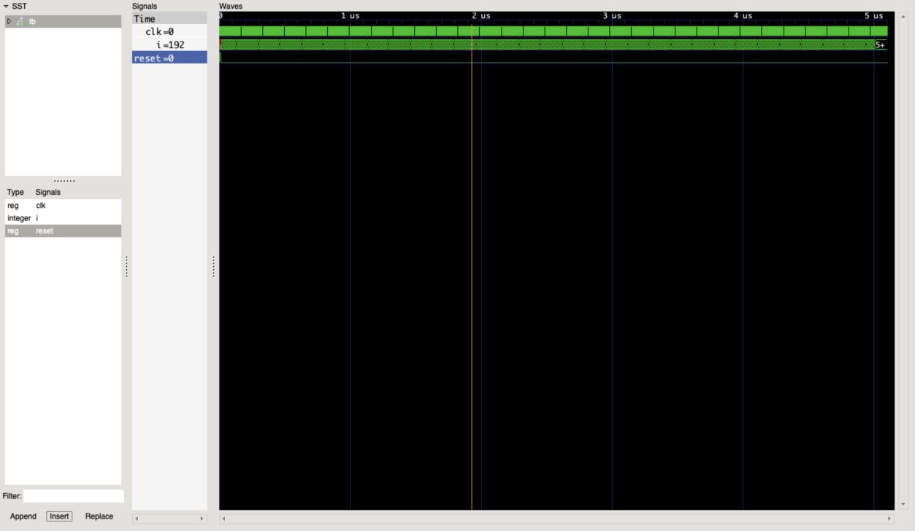

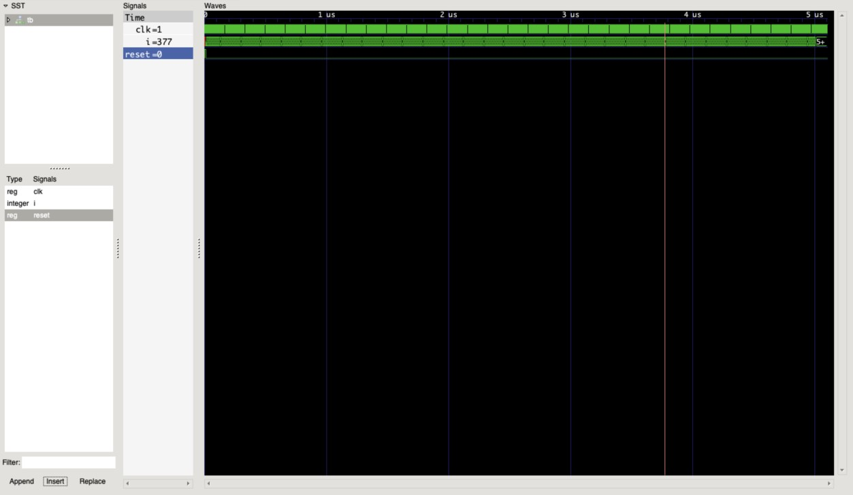

**ASSIGNMENT 4B**

**Digital Design and Computer Organization**

**UE20CS251A**

**3rd Semester, Academic Year 2021-22**

Date: 14/11/22

|  |  |  |
| --- | --- | --- |
| Name:  Nikhil Girish | SRN:  PES2UG21CS334 | Section: F |

**Question:**

Convert the following program from machine language into MIPS assembly language. The numbers on the left are the instruction addresses in memory, and the numbers on the right give the instruction at that address. Then reverse engineer a high-level program that would compile into this assembly language routine and write it. Explain in words what the program does. $a0 is the input, and it initially contains a positive number, n. $v0 is the output.

0x00400000 0x20080000 0x00400004 0x20090001

0x00400008 0x0089502A

0x0040000C 0x15400003

0x00400010 0x01094020 0x00400014 0x21290002 0x00400018 0x08100002

0x0040001C 0x01001020

0x00400020 0x03E00008

**Answer:**

After converting machine language to MIPS assembly language:

|  |  |  |  |
| --- | --- | --- | --- |
| [0x00400000] 0x20080000 [0x00400004] 0x20090001  [0x00400008] 0x0089502A |  | for: | addi $t0, $0, 0 addi $t1, $0, 1 slt $t2, $a0, $t1 |
| [0x0040000C] 0x15400003  [0x00400010] 0x01094020 |  |  | bne $t2, $0, done  add $t0, $t0, $t1 |
| [0x00400014] 0x21290002  [0x00400018] 0x08100002 |  |  | addi $t1, $t1, 2  j for |
| [0x0040001C] 0x01001020 |  | done: add $v0, $t0, $0 | |

Last line [0x00400020] 0x03E00008, is R-type jump instruction to register 11111 (31) ($ra) which signifies return statement.

**C program:**

t = $t0, i = $t1, n = $a0, res = $v0

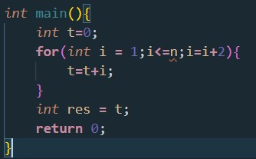

The program will sum up all the odd integers from 1 to $a0 and stores the final sum in $v0.

<https://youtu.be/c2_LwMuPs6U> Refer this link

Name: Nikhil Girish

SRN: PES2UG21CS334

Section: F

Date: 21/10/22

Assignment-3: Counters with D flipflop

Write a Verilog code and test bench for 4 bit Binary up counter designed using D Flip Flops

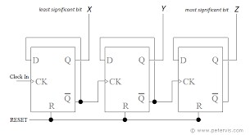

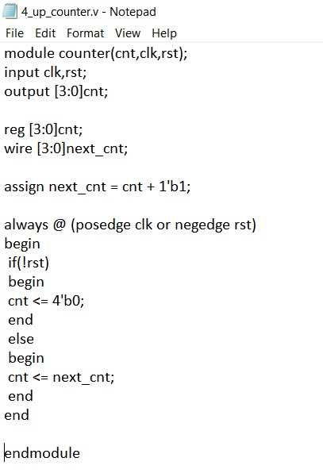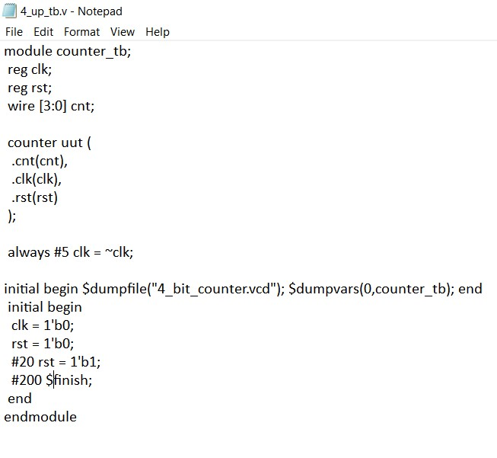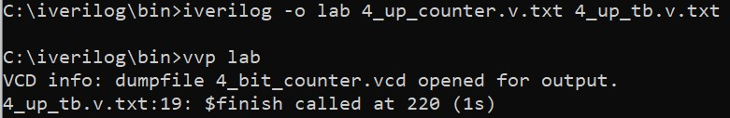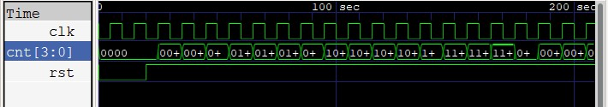

Write a Verilog code and test bench for 4-bit Ring Counter by D flipflop

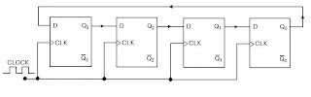

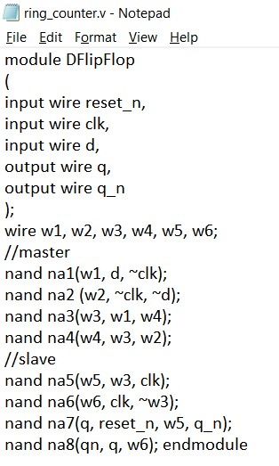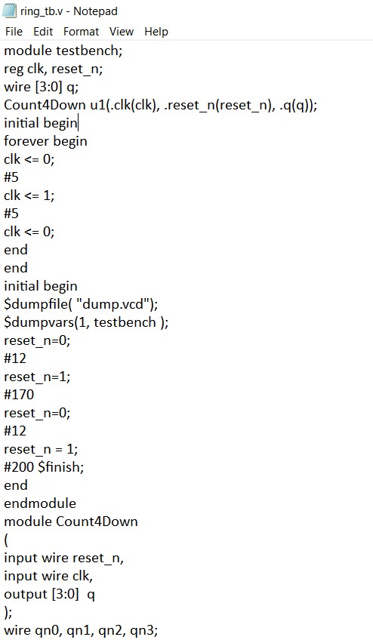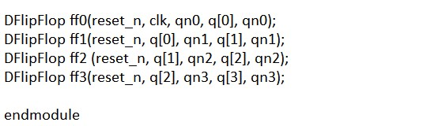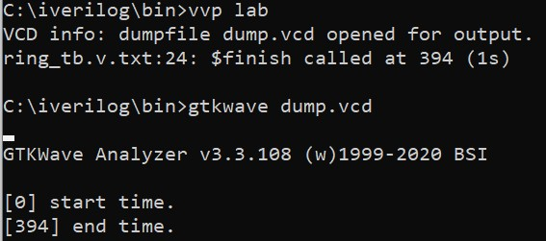

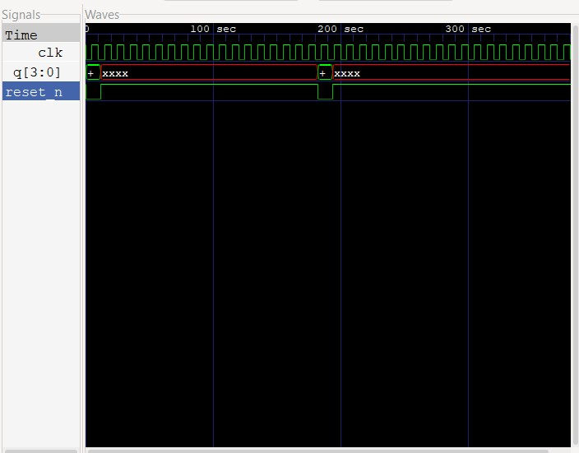

Write a Verilog code and test bench for 4-bit Johnson Counter by D flipflop

